[**File Names Are Also Vulnerable!**](https://labs.hacktify.in/HTML/html_lab/lab_3/index.php)

Upload the file from your PC.

For eg: I have uploaded abc.odt

On the intercept in the Burp Suite and upload the abc.odt.

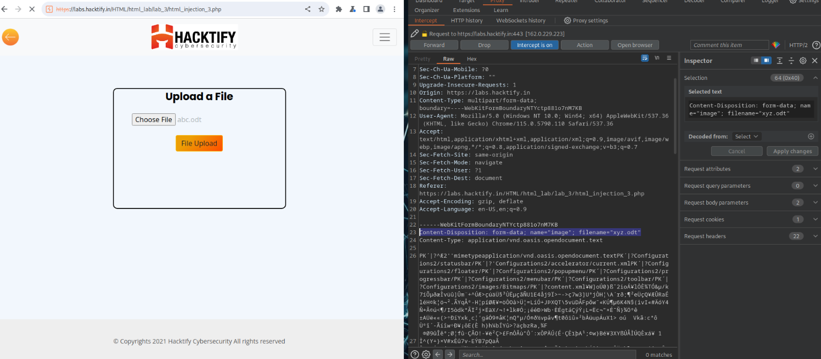

Now change the filename to xyz.odt and forward the request.

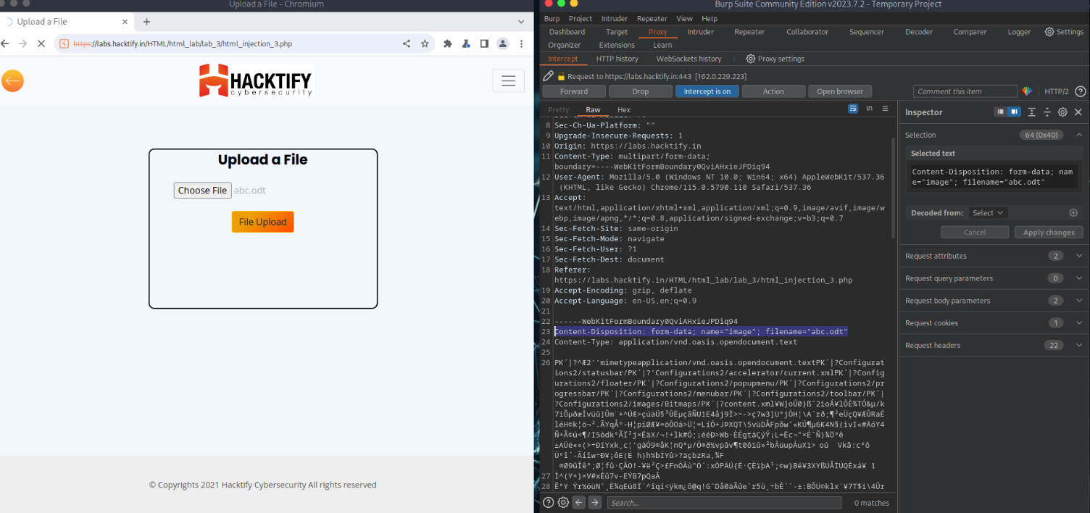

You will see that xyz.odt is uploaded

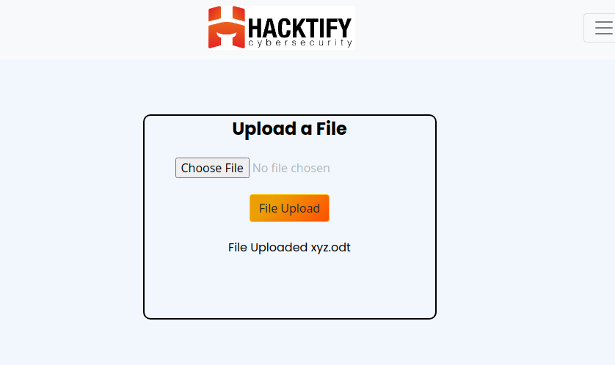

This concludes that we can change the name of the file that means it is not checking the file. It is the crafted response.